IBM UrbanCode Deploy Slack Plug-in
Overview

This Slack plug-in enables you to post status (failure/warning/success) messages to your slack team.

The plug-in step enables you to configure slack messaging from UrbanCode Deploy by populating the required fields when defining the process (located under: Notifications > Slack > Post Notification to Slack):
- Name*
- WebHook URL* (see https://api.slack.com/incoming-webhooks)
- Channel*
- Colour ( default – good )
- Emoji Icon* ( default- :thumbsup: )
- Environment* ( default-${p:environment.name} ) hidden
- Component* ( default-${p:component.name} ) hidden
- Version* ( default-${p:version..name} ) hidden

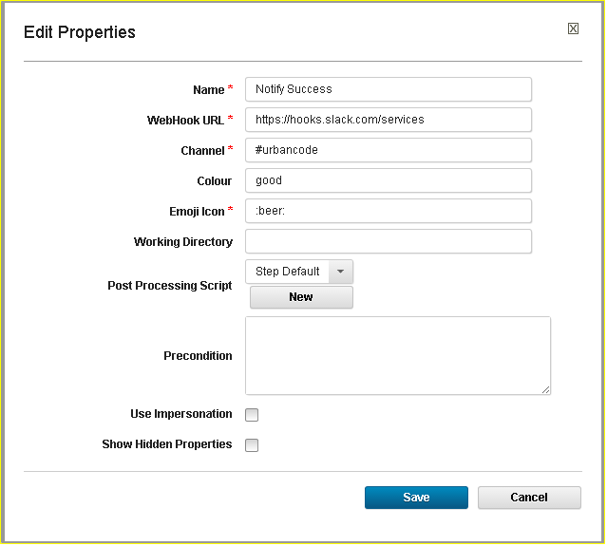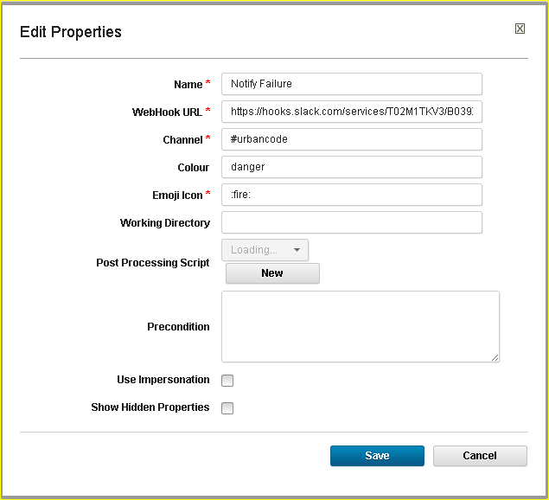

Usage

This section elaborates on the procedure to be followed to use this plug-in.
Before you begin
- Installed and started your UrbanCode Deploy Server, you can refer to
http://coltrane-new.rtp.raleigh.ibm.com/ucdeploy/index.jsp
- Installed Started the UrbanCode Deploy Agent which connects to the UrbanCode Deploy Server
- Load the Slack plug-in into the UrbanCode Deploy Server

